Dear Parent/ Carer

I would like to welcome your child to Nightingale for the new school year. Whether you are new to Nightingale or returning for another year we are privileged to be able to work alongside you to ensure your child has the best possible experience with our team.

Since the Summer term we have had some staffing changes including changes to the senior leadership team and so I wanted to take this opportunity to introduce myself and my colleagues to you.

I will be taking on the role of Executive Headteacher at Co-op Academy Nightingale and Co-op Academy Brownhill. I have worked in the Burmantofts community for over 20 years and I am committed to ensuring children in the area receive the best possible education. It is my strong belief that all children can achieve and be successful and it is our job as a school to develop your child's learning, talents and abilities in all subjects. Listening to the views of your family and your child will sit at the heart of our decision making and I would encourage you to chat to a member of our team if you have any suggestions or feedback which will help us to become a better Academy. I also know that not all decisions we make can please everyone but I can assure you that changes and improvements we make will always be aimed at improving your child’s learning, knowledge and experience. These things are the route to your child's success both in education and beyond and I will work to ensure that this remains at the heart of everything we do.

Working alongside me will be Mr Phillips and Miss Lewis. Miss Lewis is new to the Academy but has worked as a Deputy head for many years at Co-op Academy Woodlands. She has a wealth of experience and is committed to ensuring your child is successful in their learning. Many of you will already know Mr Phillips who has worked at Nightingale for a number of years, he is a dedicated member of the team and is truly passionate about the children and families at Nightingale (He has already told me so much about their successes and events from the past year.) Mr Phillips and Miss Lewis will be working together and will be responsible for the day to day running of the Academy. Should you need to speak to any of us we will be visible at the beginning and end of the school day or you can make an appointment at the school office. Please come and say hello to us as we love to chat about your child’s learning and or about improvements we can make to the academy.

I have also included a list of the other key staff so that you know who to speak on any occasion.

Assistant Heads- Mrs Tanday and Mrs Zielinski
Family support- Miss Crispin and Mrs Begum
Pastoral team- Mrs Packer and Miss Hughes
Office Team - Mrs Pritchard, Mrs Kauser, Miss Bassue and Ms Newland
Caretaker- Mr Watts
Year groups:
Reception- Miss Spencer and Miss Cain
Year 1- Miss Nutting and Miss Martin
Year 2- Miss Sharlotte and Mr Illingworth
Year 3- Miss Banyard and Mr Currie
Year 4- Miss Springer, Miss Ahmet and Miss Ali
Year 5- Miss Baldwin and Miss Horsfall
Year 6- Mr Rhodes-Hey and Mr Smith

Changes to Morning routines.

We are making some changes to our morning routine at Nightingale. This is to ensure that pupils can arrive safely in classrooms, that learning starts as soon as pupils enter the classroom and that external doors to the building can be closed to safeguard children once they are learning.
As from tomorrow pupils in year 1- 6 will all have a designated space to line up in their classes before entering the class.
- At 8:44 a whistle will blow and children can begin to line up.
- At 8:45 the class teacher will meet the pupils in the line
- At 8:48 Pupils will be escorted into the building and the classroom doors will close.
- Pupils who arrive later than 8:48 will be asked to go into the late gate which is at the front of the building in the hall doors
Children will be collected from the same exit as they enter the building.
Below is a map of the entrances that your child will use tomorrow. Staff will be on hand to guide you in the morning.
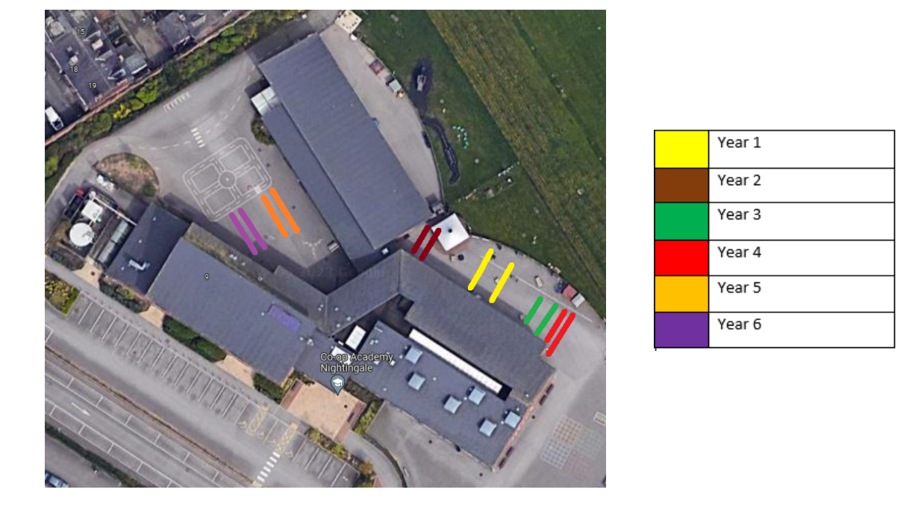

Please visit our new website for further information about us and the upcoming school year including term dates.
https://www.nightingale.coopacademies.co.uk

Finally I have attached a short questionnaire and I would really appreciate your thoughts and feedback so that we can make the right improvements and changes in the coming year. Feel free to answer all or just some of the questions and then return it to the class teacher or the main office.

Yours sincerely



Mrs B Blanchfield
Executive Head Teacher

Parents Thoughts and Feedback

We would really appreciate your thoughts and feedback so that we can work alongside families to make Co-op Academy Nightingale the best it can be. Your opinions matter to us!

Please circle on a scale of 1-10 1 being poor and 10 being excellent your thoughts on the following issues.

How likely would you be to recommend Co-op Academy Nightingale to other families?

1 2 3 4 5 6 7 8 9 10

How good is communication between the Academy and you?

1 2 3 4 5 6 7 8 9 10

Does your child enjoy coming to the Academy?

1 2 3 4 5 6 7 8 9 10

Do you have enough opportunities to visit the Academy?

1 2 3 4 5 6 7 8 9 10

Do you think the Academy is a welcoming environment?

1 2 3 4 5 6 7 8 9 10

Do you feel that your child is getting good teaching and learning experiences?

1 2 3 4 5 6 7 8 9 10

Please include any more detailed comments about the above questions here. The more detail we have the better we can work to make improvements when they are needed.
………………………………………………………………………………………………………………………………………………………………………………………………………………………………………………………………………………………………………………………………………………………………

What thing/s would you like to see change about Co-op Academy Nightingale in the next year?
………………………………………………………………………………………………………………………………………………………………………………………………………………………………………………………………………………………………………………………………………

What do you think works really well at the Academy and that you would want to stay the same?
……………………………………………………………………………………………………………………………………………………………………………………………………………………………………………………………………………………………………………………………………………………………………………………………………………………………………………………………………………………

What Year group is your child/ Children in? Please circle all that apply

Reception Yr1 Yr2 Yr3 Yr4 Yr5 Yr6
Thank you for taking the time to complete this.

